**Table 1.**

|  |  |  |  |  |  |  |
| --- | --- | --- | --- | --- | --- | --- |
|  | **Europe (N=4071)** | **Center A (N=983)** | **Center B (N=1343)** | **Center C (N=566)** | **Center D (N=1179)** | **Validation (N-4827)** |
| **Positive SN status** | 889 (21.8%) | 236 (24.0%) | 259 (19.3%) | 170 (30.0%) | 224 (19.0%) | 893 (18.5%) |
| **Males** | 1996 (49.0%) | 497 (50.6%) | 753 (56.1%) | 273 (48.2%) | 473 (40.1%) | 2860 (59.3%) |
| **Age** |  |  |  |  |  |  |
| Median (Q1, Q3) | 55.0 (43.0, 66.0) | 55.0 (43.0, 65.0) | 62.0 (48.0, 71.0) | 52.0 (40.0, 62.0) | 51.0 (42.0, 62.0) | 58.0 (46.0, 68.0) |
| Min - Max | 13.0 - 94.0 | 15.0 - 89.0 | 13.0 - 94.0 | 13.0 - 88.0 | 15.0 - 83.0 | 5.0 - 94.0 |
| **Ulceration** | 1171 (28.8%) | 265 (27.0%) | 263 (19.6%) | 166 (29.3%) | 477 (40.5%) | 1298 (26.9%) |
| Missing | 141 (3.5%) | 30 (3.1%) | 31 (2.3%) | 68 (12.0%) | 12 (1.0%) | 279 (5.8%) |
| **Location** |  |  |  |  |  |  |
| Arm | 615 (15.1%) | 128 (13.0%) | 217 (16.2%) | 86 (15.2%) | 184 (15.6%) | 893 (18.5%) |
| Leg | 1189 (29.2%) | 277 (28.2%) | 324 (24.1%) | 218 (38.5%) | 370 (31.4%) | 1240 (25.7%) |
| Trunk | 1815 (44.6%) | 407 (41.4%) | 654 (48.7%) | 242 (42.8%) | 512 (43.4%) | 1858 (38.5%) |
| Head/neck | 314 (7.7%) | 138 (14.0%) | 142 (10.6%) | 20 (3.5%) | 14 (1.2%) | 836 (17.3%) |
| Missing | 138 (3.4%) | 33 (3.4%) | 6 (0.4%) | 0 (0.0%) | 99 (8.4%) | 0 (0.0%) |
| **Histology** |  |  |  |  |  |  |
| SSM | 2164 (53.2%) | 598 (60.8%) | 910 (67.8%) | 285 (50.4%) | 371 (31.5%) | 1984 (41.1%) |
| NM | 1226 (30.1%) | 276 (28.1%) | 290 (21.6%) | 195 (34.5%) | 465 (39.4%) | 1562 (32.4%) |
| ALM | 126 (3.1%) | 29 (3.0%) | 54 (4.0%) | 16 (2.8%) | 27 (2.3%) | 89 (1.8%) |
| Other | 202 (5.0%) | 53 (5.4%) | 46 (3.4%) | 14 (2.5%) | 89 (7.5%) | 561 (11.6%) |
| Missing | 353 (8.7%) | 27 (2.7%) | 43 (3.2%) | 56 (9.9%) | 227 (19.3%) | 631 (13.1%) |
| **Breslow** |  |  |  |  |  |  |
| Mean (SD) | 2.8 (3.3) | 2.6 (2.0) | 2.3 (2.5) | 2.8 (2.3) | 3.6 (4.9) | 2.7 (2.4) |
| Min - Max | 0.1 - 90.0 | 0.5 - 22.0 | 0.1 - 30.0 | 0.3 - 20.0 | 0.1 - 90.0 | 0.6 - 47.0 |
| Missing | 59 (1.4%) | 9 (0.9%) | 16 (1.2%) | 6 (1.1%) | 28 (2.4%) | 0 (0.0%) |
| **Multiple fields** | 374 (9.2%) | 223 (22.7%) | 41 (3.1%) | 87 (15.4%) | 23 (2.0%) | 1213 (25.1%) |
| **Total number of negative SN** |  |  |  |  |  |  |
| Mean (SD) | 1.7 (1.4) | 2.2 (1.6) | 1.6 (1.3) | 1.6 (1.4) | 1.2 (1.0) | 2.4 (1.7) |
| Min - Max | 0.0 - 15.0 | 0.0 - 15.0 | 0.0 - 13.0 | 0.0 - 10.0 | 0.0 - 9.0 | 0.0 - 17.0 |
| Missing | 162 (4.0%) | 0 (0.0%) | 27 (2.0%) | 1 (0.2%) | 134 (11.4%) | 0 (0.0%) |
| **Total number of positive SN** |  |  |  |  |  |  |
| Mean (SD) | 0.3 (0.6) | 0.3 (0.6) | 0.2 (0.4) | 0.4 (0.7) | 0.3 (0.6) | 0.2 (0.6) |
| Min - Max | 0.0 - 5.0 | 0.0 - 4.0 | 0.0 - 2.0 | 0.0 - 4.0 | 0.0 - 5.0 | 0.0 - 8.0 |
| Missing | 1 (0.0%) | 0 (0.0%) | 1 (0.1%) | 0 (0.0%) | 0 (0.0%) | 0 (0.0%) |
| **SN tumour burden** |  |  |  |  |  |  |
| Mean (SD) | 1.2 (1.3) | 1.1 (0.8) | 1.0 (0.5) | 1.1 (1.3) | 1.4 (2.0) | 1.2 (1.4) |
| Min - Max | 0.0 - 38.0 | 0.0 - 8.0 | 0.0 - 8.0 | 0.0 - 15.0 | 0.0 - 38.0 | 0.0 - 23.0 |
| Missing | 301 (7.4%) | 120 (12.2%) | 163 (12.1%) | 18 (3.2%) | 0 (0.0%) | 153 (0.0%) |
| **Location metastasis lymph** |  |  |  |  |  |  |
| Subcap | 3319 (81.5%) | 793 (80.7%) | 1123 (83.6%) | 440 (77.7%) | 963 (81.7%) | 4273 (88.5%) |
| Combined | 213 (5.2%) | 39 (4.0%) | 27 (2.0%) | 43 (7.6%) | 104 (8.8%) | - |
| Parenchymal | 86 (2.1%) | 5 (0.5%) | 11 (0.8%) | 19 (3.4%) | 51 (4.3%) | - |
| Multifocal | 45 (1.1%) | 6 (0.6%) | 9 (0.7%) | 21 (3.7%) | 9 (0.8%) | - |
| Extensive | 105 (2.6%) | 18 (1.8%) | 10 (0.7%) | 25 (4.4%) | 52 (4.4%) | - |
| Not subcap | - | - | - | - | - | 380 (7.9%) |
| Missing | 303 (7.4%) | 122 (12.4%) | 163 (12.1%) | 18 (3.2%) | 0 (0.0%) | 174 (3.6%) |
| **Mitosis > 1 mm2** | 135 (3.3%) | 50 (5.1%) | 0 (0.0%) | 85 (15.0%) | 0 (0.0%) | 206 (4.3%) |
| Missing | 3895 (95.7%) | 906 (92.2%) | 1343 (100.0%) | 467 (82.5%) | 1179 (100.0%) | 0 (0.0%) |
| **Recurrence** | 862 (21.2%) | 208 (21.2%) | 175 (13.0%) | 160 (28.3%) | 319 (27.1%) | 1352 (28.0%) |
| **Deaths** | 606 (14.9%) | 127 (12.9%) | 148 (11.0%) | 115 (20.3%) | 216 (18.3%) | 1166 (24.2%) |
| **Melanoma specific mortality** | 504 (12.4%) | 98 (10.0%) | 101 (7.5%) | 102 (18.0%) | 203 (17.2%) | 765 (15.8%) |
| **Follow-up time in years** | 4.79 [4.60; 4.94] | 4.75 [4.48; 4.98] | 2.73 [2.46; 3.03] | 6.33 [6.06; 7.07] | 6.19 [5.91; 6.73] | 5.02 [4.89; 5.14] |

Abbreviations: Q1, first quantile (Q1); Q3, third quantile; SD, standard deviation; SN, sentinel node, SSM, superficial spreading melanoma; NM, nodular melanoma; ALM, acral lentiginous melanoma.

**Table 2.**

|  |  |  |  |  |  |  |
| --- | --- | --- | --- | --- | --- | --- |
|  | **Negative SN** | | **Positive SN** | | **Importance** | |
|  | **HR** | **CI** | **HR** | **CI** | **Main** | **Int.** |
| **Positive SN status** |  |  | 2.93 | [2.44; 3.53] | 138 |  |
| **Age**  (i.q.r. 66 versus 43 years) | 1.21 | [1.08; 1.35] | 1.21 | [1.08; 1.35] | 11 |  |
| **Ulceration** | 1.60 | [1.36; 1.88] | 1.60 | [1.36; 1.88] | 32 |  |
| **Location** |  |  |  |  | 19 |  |
| Arm | (ref) |  | (ref) |  |  |  |
| Leg | 1.30 | [0.99; 1.69] | 1.30 | [0.99; 1.69] |  |  |
| Trunk | 1.46 | [1.13; 1.88] | 1.46 | [1.13; 1.88] |  |  |
| Head and neck | 1.98 | [1.44; 2.72] | 1.98 | [1.44; 2.72] |  |  |
| **Breslow** **thickness**  (i.q.r. 3.5 versus 1.2 mm) | 2.57 | [2.26; 2.93] | 1.59 | [1.34; 1.88] | 218 | 21 |
| **SN tumour burden** |  |  | 5.15 | [2.51; 10.59] | 20 |  |
| *C-index1* | 0.76 | [0.75; 0.78] |  |  |  |  |
| *C-index recalibrated MSM1* | 0.79 | [0.77; 0.81] |  |  |  |  |

**In text**

Association between linear predictors of recurrence and MSM was even stronger / was of the same size (calibration slope: 1.14 [1.03; 1.25]).

**Prevalence using Kaplan-Meier estimates (that take into account censoring)**

|  |  |  |  |  |  |  |  |  |  |
| --- | --- | --- | --- | --- | --- | --- | --- | --- | --- |
|  | Training data | | | |  | Validation data | | | |
| Patients | N | (%) | Recurrence (%) | MSM (%) |  | N | (%) | Recurrence (%) | MSM (%) |
| All | 4,071 | 100 | 24.5 | 13.5 |  | 4,827 | 100 | 41.2 | 16.7 |
| Negative | 3,182 | 78.2 | 18.0 | 8.9 |  | 3,934 | 81.5 | 33.2 | 11.7 |
| Positive | 889 | 21.8 | 48.7 | 30.9 |  | 893 | 18.5 | 72.9 | 34.5 |

MSM = Melanoma-specific mortality

**Figure 1a.**

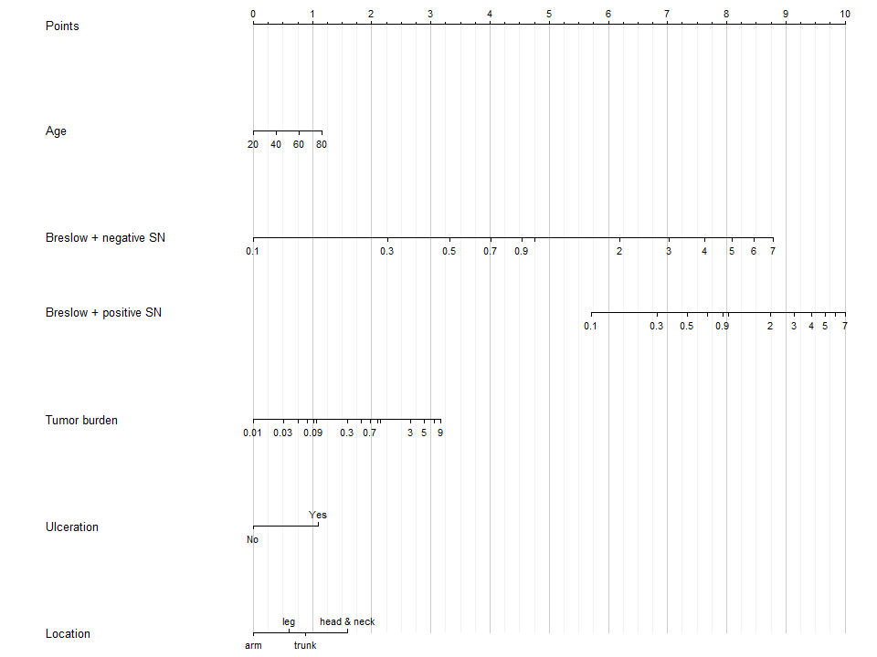**Figure 1b.**

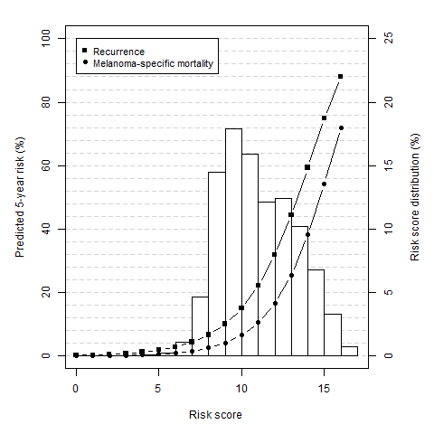

**Figures validation.**

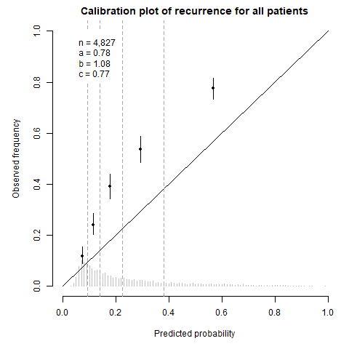

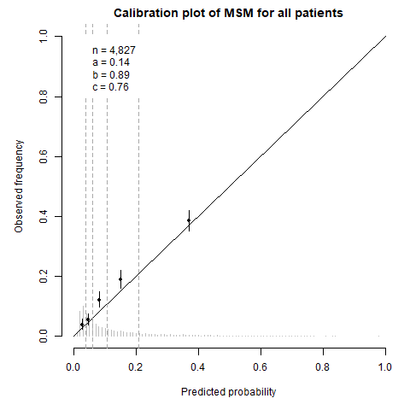

**SUPPLEMENT**

**Table S1.**

|  |  |  |  |  |  |  |
| --- | --- | --- | --- | --- | --- | --- |
|  | **Negative** | | **Positive** | | **Importance** | |
|  | **HR** | **CI** | **HR** | **CI** | **Main** | **Int.** |
| **Positive SN status** |  |  | 3.40 | [2.61; 4.44] | 87 |  |
| **Age**  (i.q.r. 66 versus 43 years) | 1.18 | [1.00; 1.38] | 1.18 | [1.00; 1.38] | 4 |  |
| **Ulceration** | 1.83 | [1.47; 2.28] | 1.83 | [1.47; 2.28] | 30 |  |
| **Location** |  |  |  |  | 16 |  |
| Arm | (ref) |  | (ref) |  |  |  |
| Leg | 0.96 | [0.66; 1.41] | 0.96 | [0.66; 1.41] |  |  |
| Trunk | 1.44 | [1.00; 2.06] | 1.44 | [1.00; 2.06] |  |  |
| Head and neck | 1.74 | [1.10; 2.74] | 1.74 | [1.10; 2.74] |  |  |
| **Breslow** **thickness**  (i.q.r. 3.5 versus 1.2 mm) | 2.78 | [2.30; 3.36] | 1.60 | [1.27; 2.01] | 123 | 14 |
| **SN tumour burden** |  |  | 7.27 | [2.65; 19.94] | 15 |  |
| *C-index1* | 0.76 | [0.74; 0.78] |  |  |  |  |

**Table S2.**

|  |  |  |  |  |  |  |  |  |  |  |  |
| --- | --- | --- | --- | --- | --- | --- | --- | --- | --- | --- | --- |
|  | Training data | | | | |  | Validation data | | | | |
|  | AJCC7 | |  | AJCC8 | |  | AJCC7 | |  | AJCC8 | |
|  | C-index1 | CI |  | C-index1 | CI |  | C-index1 | CI |  | C-index1 | CI |
| All patients | 0.73 | [0.72; 0.75] |  | 0.74 | [0.72; 0.75] |  | 0.74 | [0.72; 0.75] |  | 0.74 | [0.72; 0.75] |
| Positive SN status | 0.58 | [0.55; 0.60] |  | 0.62 | [0.59; 0.64] |  | 0.61 | [0.59; 0.64] |  | 0.63 | [0.61; 0.66] |
| Negative SN status | 0.71 | [0.69; 0.74] |  | 0.71 | [0.69; 0.74] |  | 0.69 | [0.67; 0.71] |  | 0.68 | [0.66; 0.71] |

**Figure S1.**

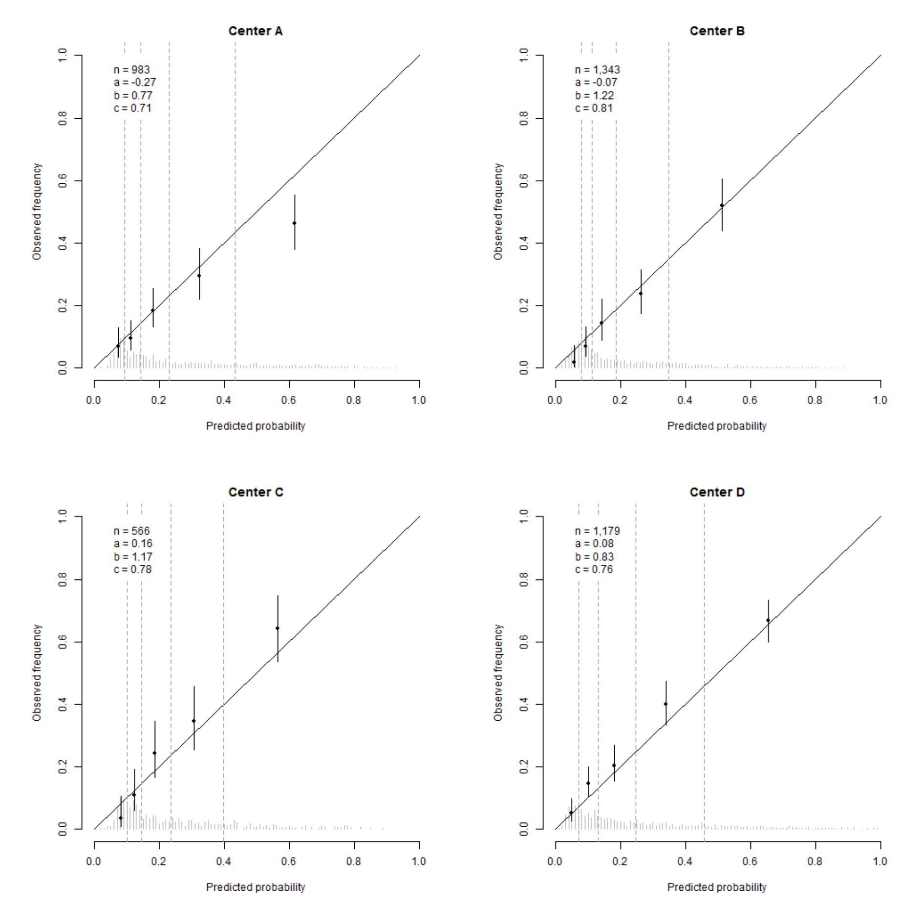

**Figure S2.**

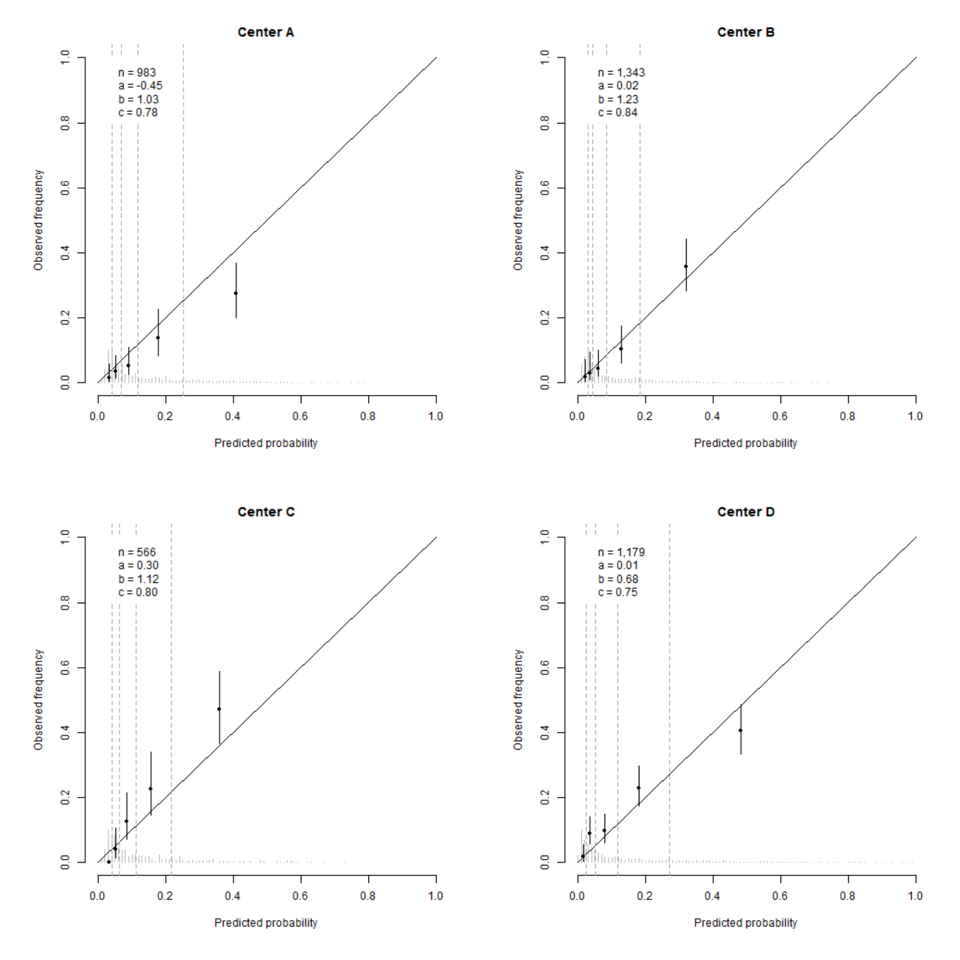

**Figure S3.**

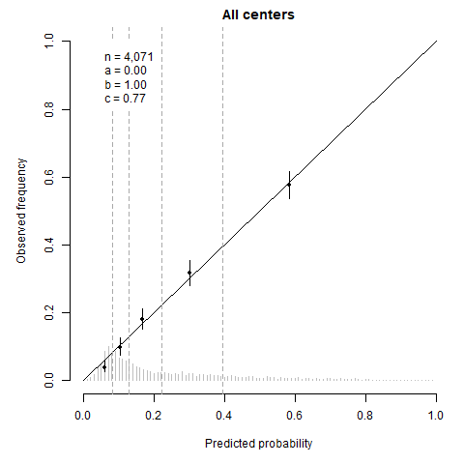

**Figure S4.**

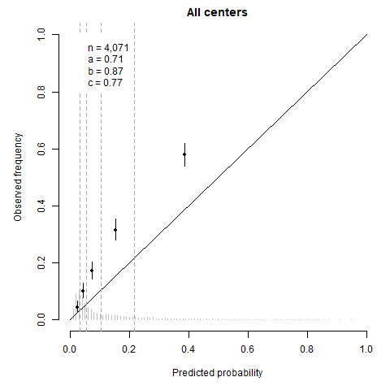

**NOT USED**

**Table S1. Average number of patients in each class of AJCC7 and AJCC8 of the five imputed data sets.**

|  |  |  |  |  |  |
| --- | --- | --- | --- | --- | --- |
|  | Training data | |  | Validation data | |
| Class | AJCC7 | AJCC8 |  | AJCC7 | AJCC8 |
| IA | 217 | 253 |  | 370 | 0 |
| IB | 1532 | 1496 |  | 1574 | 1944 |
| IIA | 692 | 692 |  | 1065 | 1065 |
| IIB | 495 | 495 |  | 663 | 663 |
| IIC | 250 | 250 |  | 262 | 262 |
| IIIA | 471 | 199 |  | 531 | 248 |
| IIIB | 407 | 208 |  | 352 | 192 |
| IIIC | 8 | 476 |  | 10 | 450 |
| IIID* | 0 | 4 |  | 0 | 3 |

*Class IIID is not a class defined by the AJCC7.

**In text**

The date of recurrence was missing for 45 (1.1%) patients, whilst it was indicated that recurrence did occur within the follow-up time. The majority of these patients were from centre D (42 patients, 7.4%), two patients from centre B (0.1%), and one patient from centre A (0.1%). The time-to-recurrence for these 45 patients was imputed using single imputation.

**Table. Full model predicting 5-year recurrence**. This Table displays the hazard ratios together with the 95 percent confidence intervals of the full Cox proportional hazards model predicting 5-year recurrence.

|  |  |  |  |  |  |  |
| --- | --- | --- | --- | --- | --- | --- |
|  | **Negative SN** | | **Positive SN** | | **Importance** | |
|  | **HR** | **CI** | **HR** | **CI** | **Main** | **Int.** |
| **Positive SN status** |  |  | 4.021 | [2.04; 7.92] | 41 | 25 |
| **Male** | 1.25 | [1.03; 1.53] | 0.98 | [0.78; 1.23] | 5 | 3 |
| **Age**  (i.q.r. 66 versus 43 years) | 1.11 | [0.96; 1.29] | 1.29 | [1.08; 1.53] | 10 | 2 |
| **Ulceration** | 1.65 | [1.33; 2.05] | 1.40 | [1.10; 1.78] | 28 | 1 |
| **Location** |  |  |  |  | 20 | 1 |
| Arm | (ref) |  | (ref) |  |  |  |
| Leg | 1.44 | [1.05; 1.98] | 1.08 | [0.62; 1.90] |  |  |
| Trunk | 1.50 | [1.10; 2.05] | 1.14 | [0.66; 1.96] |  |  |
| Head and neck | 2.33 | [1.57; 3.46] | 1.53 | [0.80; 2.92] |  |  |
| **Histology** |  |  |  |  | 10 | 0 |
| SSM | (ref) |  | (ref) |  |  |  |
| NM | 1.30 | [1.03; 1.64] | 1.29 | [0.99; 1.68] |  |  |
| ALM | 1.43 | [0.83; 2.45] | 1.39 | [0.80; 2.40] |  |  |
| Other | 1.00 | [0.64; 1.57] | 1.15 | [0.50; 2.66] |  |  |
| **Breslow** **thickness**  (i.q.r. 3.5 versus 1.2 mm) | 2.40 | [2.06; 2.80] | 1.56 | [1.30; 1.88] | 147 | 12 |
| **Multiple fields** | 1.52 | [1.10; 2.10] | 1.46 | [1.05; 2.02] | 11 | 0 |
| **Total number of negative nodes** | 0.95 | [0.90; 1.01] | 0.95 | [0.90; 1.01] | 3 |  |
| **Total number of positive nodes** |  |  | 0.98 | [0.82; 1.17] | 0 |  |
| **SN tumour burden**  (i.q.r. 38 versus 0.01) |  |  | 3.61 | [1.30; 10.00] | 6 |  |
| **Location metastasis in lymph node** |  |  |  |  | 6 |  |
| Subcap |  |  | (ref) |  |  |  |
| Combined |  |  | 1.40 | [0.93; 2.10] |  |  |
| Parenchymal |  |  | 0.96 | [0.58; 1.60] |  |  |
| Multifocal |  |  | 0.90 | [0.52; 1.55] |  |  |
| Extensive |  |  | 1.22 | [0.74; 2.02] |  |  |
| *C-index2* | 0.77 | [0.75; 0.78] |  |  |  |  |
| *C-index recalibrated MSM2* | 0.79 | [0.77; 0.81] |  |  |  |  |

1The hazard ratio of positive sentinel node patients includes the effects from the interaction terms. 2The C-index is corrected for optimism. Abbreviations: SN, sentinel node; HR, hazard ratio; CI, 95 percent confidence interval; Importance defined by the chi-square Wald-statistic; Main the Wald-statistic for the main effect of the coefficient; Int., the Wald-statistic for the interaction term with positive SN status; SSM, superficial spreading melanoma; NM, nodular melanoma; ALM, acral lentiginous melanoma; MSM, melanoma specific mortality.

**Table. Refitted full model predicting 5-year melanoma specific mortality**. This Table displays the hazard ratios together with the 95 percent confidence intervals of the refitted full Cox proportional hazards model predicting 5-year melanoma specific mortality.

|  |  |  |  |  |  |  |
| --- | --- | --- | --- | --- | --- | --- |
|  | **Negative SN** | | **Positive SN** | | **Importance** | |
|  | **HR** | **CI** | **HR** | **CI** | **Main** | **Int.** |
| **Positive SN status** |  |  | 6.441 | [2.54; 16.31] | 38 | 30 |
| **Male** | 1.65 | [1.22; 2.24] | 1.21 | [0.89; 1.64] | 12 | 2 |
| **Age**  (i.q.r. 66 versus 43 years) | 0.93 | [0.74; 1.16] | 1.39 | [1.09; 1.76] | 8 | 6 |
| **Ulceration** | 2.06 | [1.51; 2.80] | 1.64 | [1.20; 2.24] | 30 | 1 |
| **Location** |  |  |  |  | 15 | 4 |
| Arm | (ref) |  | (ref) |  |  |  |
| Leg | 1.13 | [0.69; 1.83] | 0.86 | [0.44; 1.69] |  | 3.9 |
| Trunk | 1.80 | [1.15; 2.81] | 0.94 | [0.48; 1.83] |  |  |
| Head and neck | 1.81 | [0.97; 3.37] | 1.56 | [0.75; 3.28] |  |  |
| **Histology** |  |  |  |  | 5 | 1 |
| SSM | (ref) |  | (ref) |  |  |  |
| NM | 1.36 | [0.95; 1.93] | 1.14 | [0.83; 1.59] |  | 0.4 |
| ALM | 1.51 | [0.63; 3.64] | 1.27 | [0.59; 2.76] |  |  |
| Other | 1.00 | [0.48; 2.07] | 0.71 | [0.16; 3.06] |  |  |
| **Breslow** **thickness**  (i.q.r. 3.5 versus 1.2 mm) | 2.54 | [2.02; 3.18] | 1.58 | [1.24; 2.01] | 76 | 8 |
| **Multiple fields** | 1.22 | [0.76; 1.97] | 1.49 | [0.98; 2.27] | 4 | 0 |
| **Total number of negative nodes** | 0.94 | [0.86; 1.03] | 0.94 | [0.86; 1.03] | 2 |  |
| **Total number of positive nodes** |  |  | 0.99 | [0.79; 1.25] | 0 |  |
| **SN tumour burden**  (i.q.r. 38 versus 0.01) |  |  | 4.74 | [1.11; 20.25] | 4 |  |
| **Location metastasis in lymph node** |  |  |  |  | 2 |  |
| Subcap |  |  | (ref) |  |  |  |
| Combined |  |  | 1.08 | [0.66; 1.76] |  |  |
| Parenchymal |  |  | 1.23 | [0.63; 2.37] |  |  |
| Multifocal |  |  | 1.19 | [0.60; 2.34] |  |  |
| Extensive |  |  | 1.42 | [0.74; 2.72] |  |  |
| *C-index2* | 0.76 | [0.74; 0.77] |  |  |  |  |

1The hazard ratio of positive sentinel node patients includes the effects from the interaction terms. 2The C-index is corrected for optimism. Abbreviations: SN, sentinel node; HR, hazard ratio; CI, 95 percent confidence interval; Importance defined by the chi-square Wald-statistic; Main the Wald-statistic for the main effect of the coefficient; Int., the Wald-statistic for the interaction term with positive SN status; SSM, superficial spreading melanoma; NM, nodular melanoma; ALM, acral lentiginous melanoma.

**Figure. Calibration curves of the final model predicting recurrence for each centre only for positive sentinel node patients obtained using leave-one-out internal-external validation.**

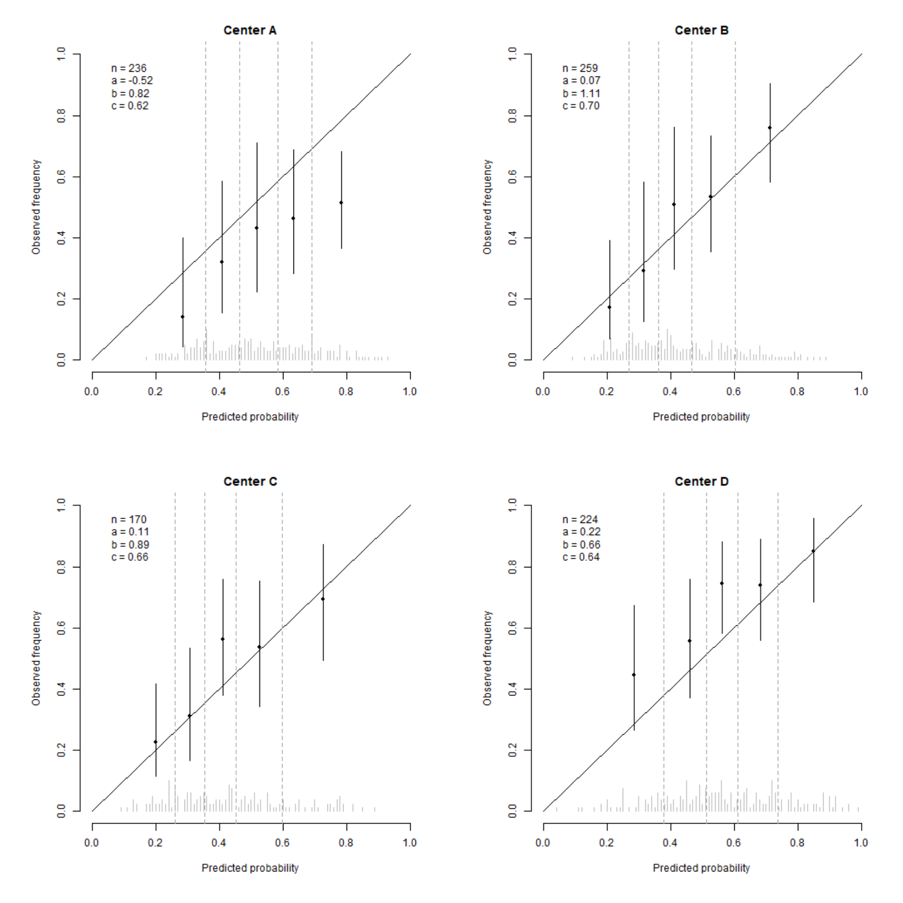

**Figure. Calibration curves of the final calibrated model predicting melanoma specific mortality for each centre only for positive sentinel node patients obtained using leave-one-out internal-external validation.**

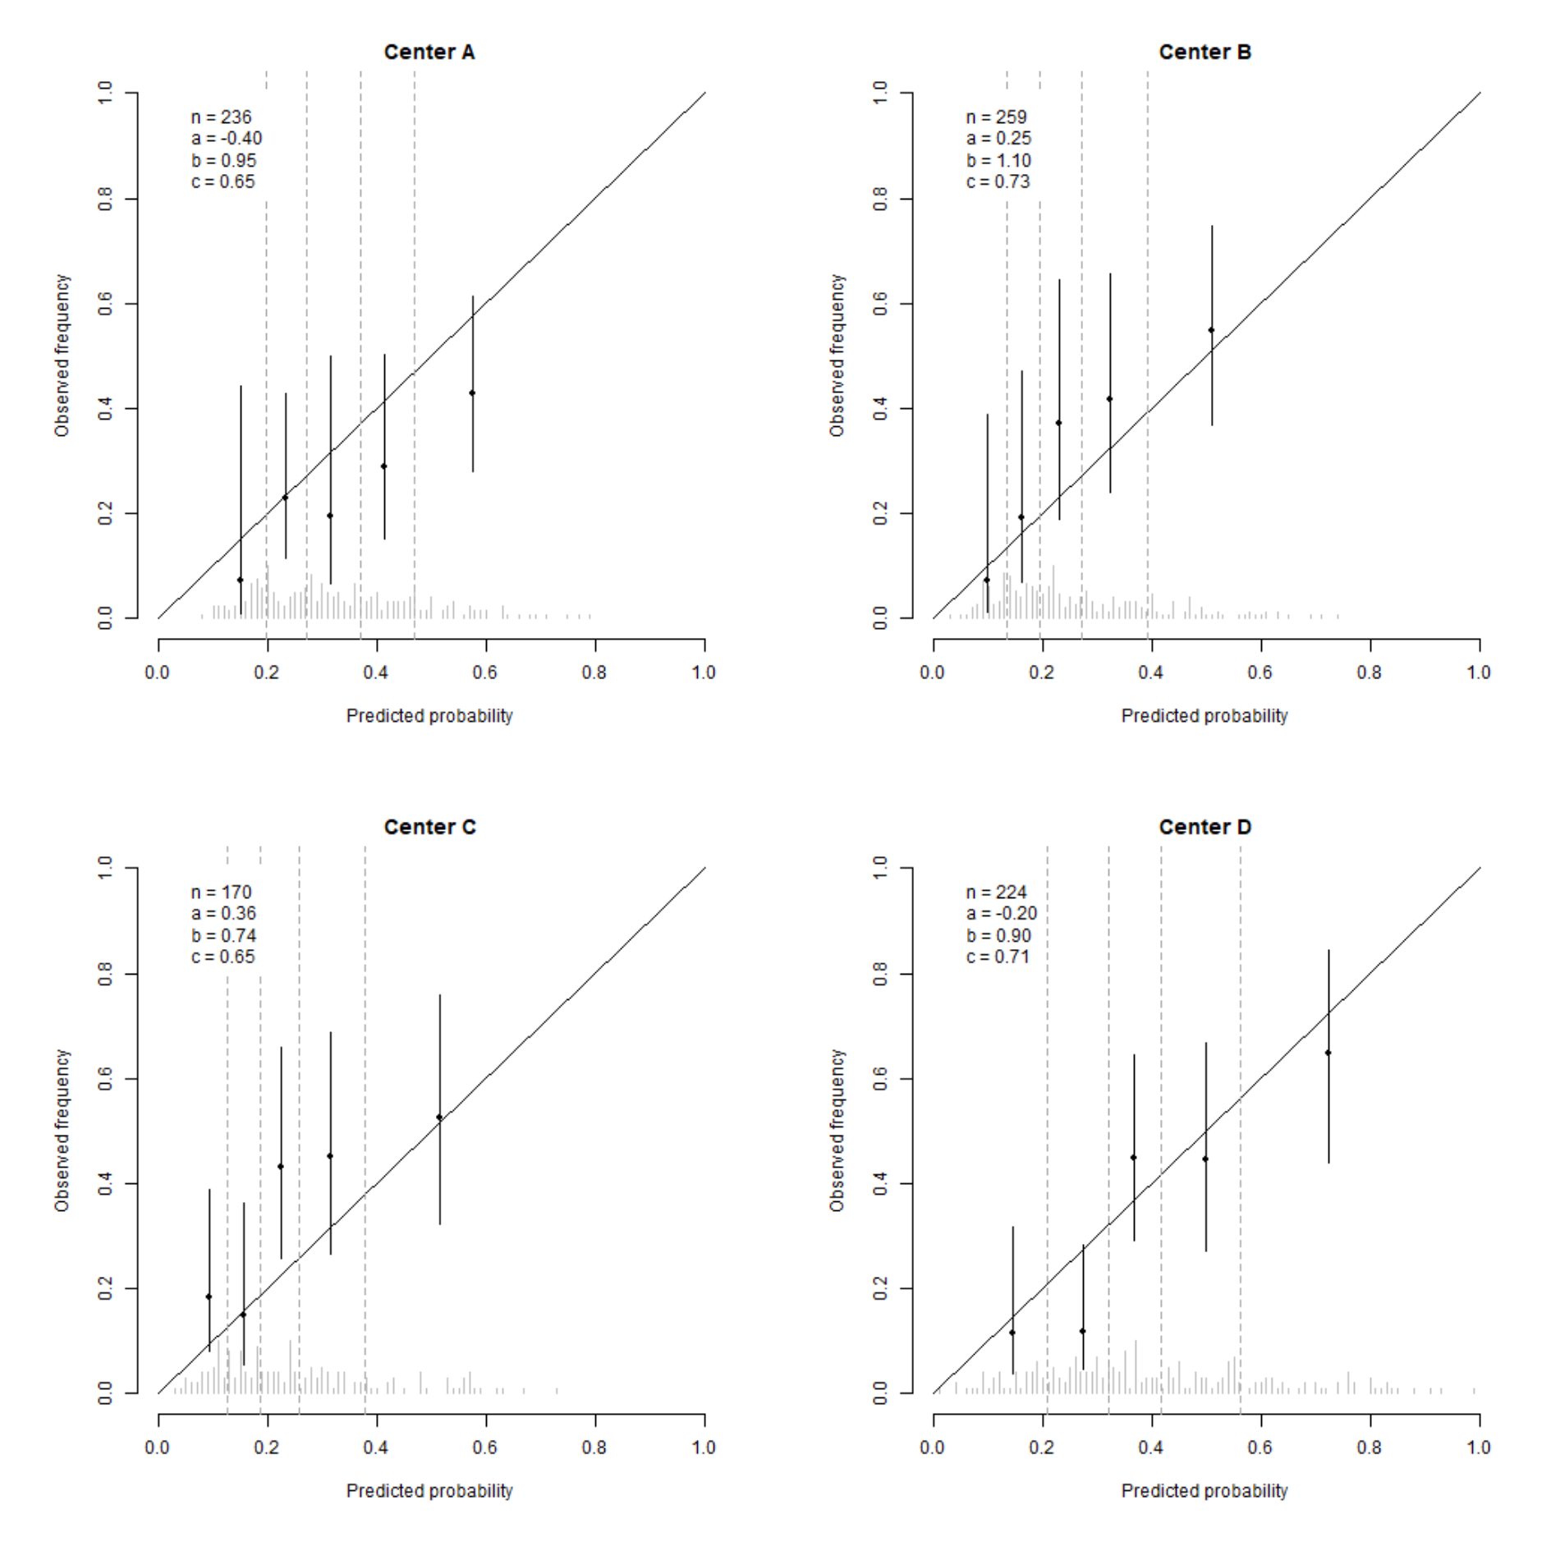

**Figure. Calibration curves of the final model predicting recurrence for each centre only for negative sentinel node patients obtained using leave-one-out internal-external validation.**

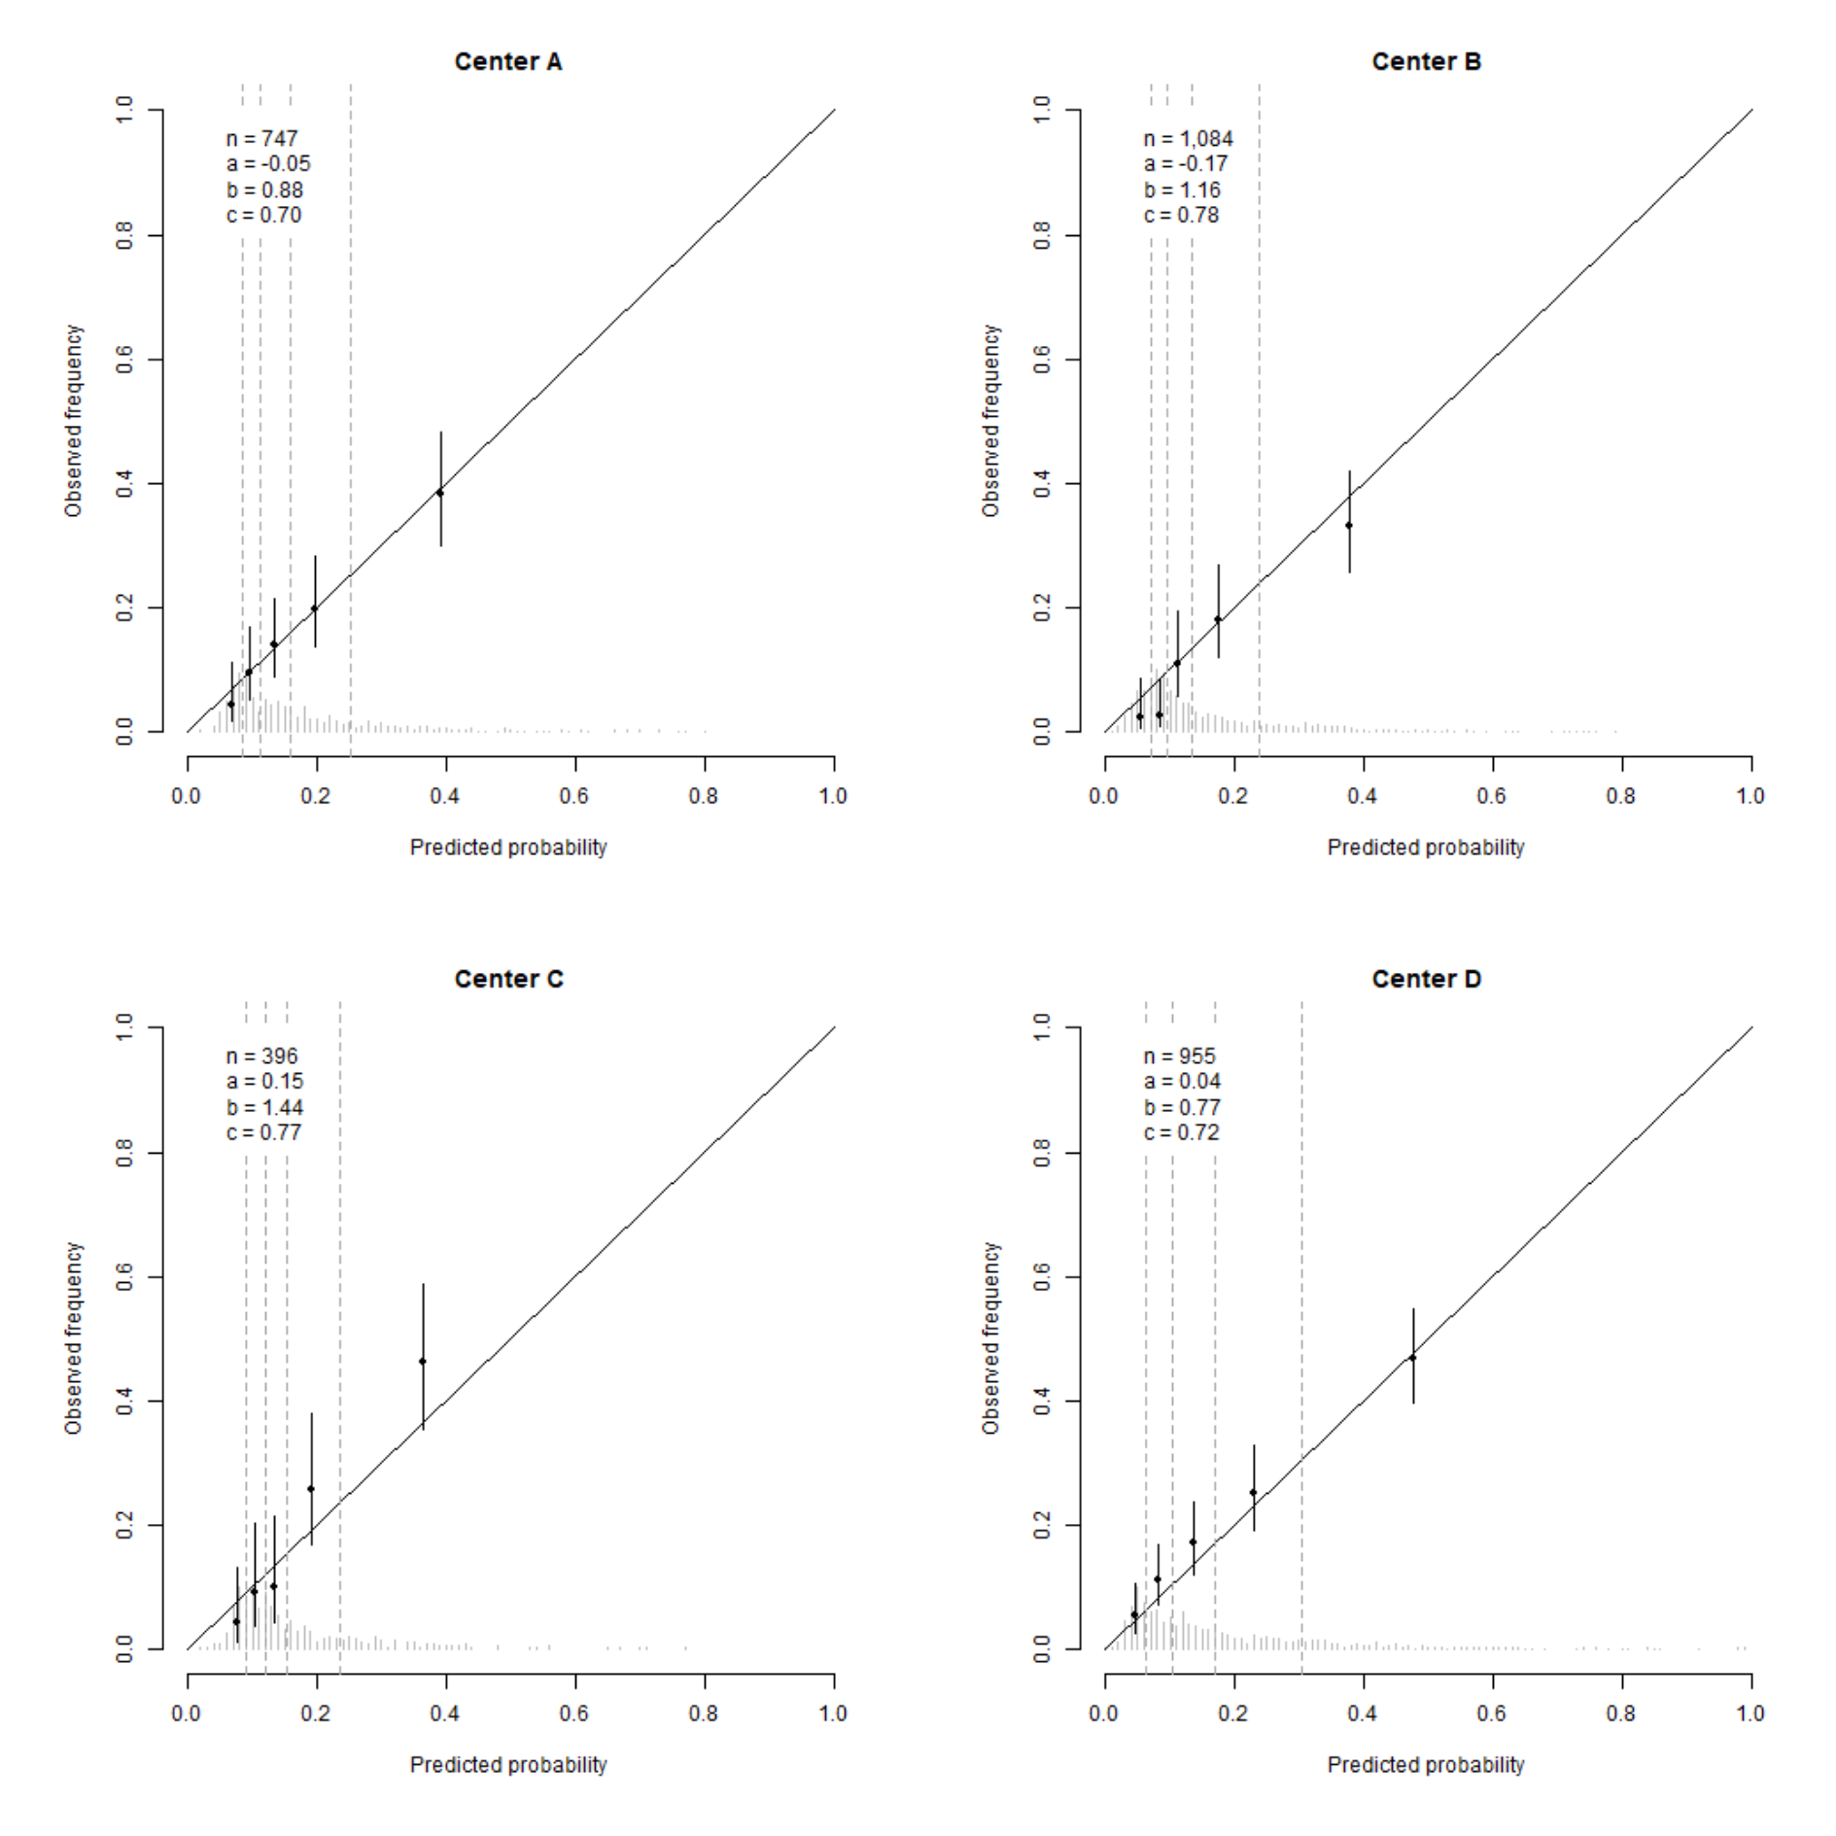

**Figure. Calibration curves of the final calibrated model predicting melanoma specific mortality for each centre only for negative sentinel node patients obtained using leave-one-out internal-external validation.**

